Appendix

Decoding the role of process variables in shaping the properties of magnesium potassium phosphate bone cement: insights from a systematic study
Marcin Wekwejt^{*1}, Kaja Stanisławska², Aleksandra Mielewczyk-Gryń³, Anna Ronowska⁴

¹ Department of Biomaterials Technology, Faculty of Mechanical Engineering and Ship Technology, Gdańsk University of Technology, Gdańsk, Poland
² Scientific Club ‘Materials in Medicine’, Advanced Materials Centre, Gdańsk University of Technology, Gdańsk, Poland
³ Division of Ceramics, Faculty of Applied Physics and Mathematics, Gdańsk University of Technology, Gdańsk, Poland
⁴ Chair of Clinical Biochemistry, Department of Laboratory Medicine, Medical University of Gdańsk, Gdańsk, Poland
* marcin.wekwejt@pg.edu.pl

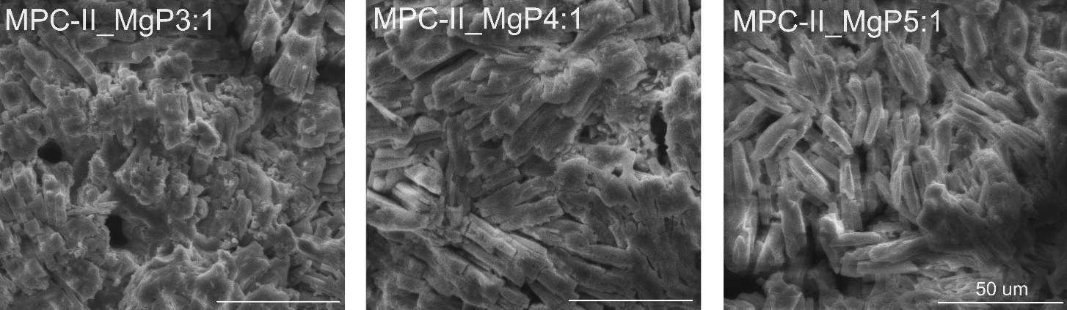
Fig. S1. SEM images of tested magnesium potassium bone cements obtained with MgO-II with various Mg/P ratio (P/L ratio – constant = 2.5:1) at 1000x magnification after curing (the pictures are representative of three specimens)

